ATIVIDADES 9 ANOS 27-03

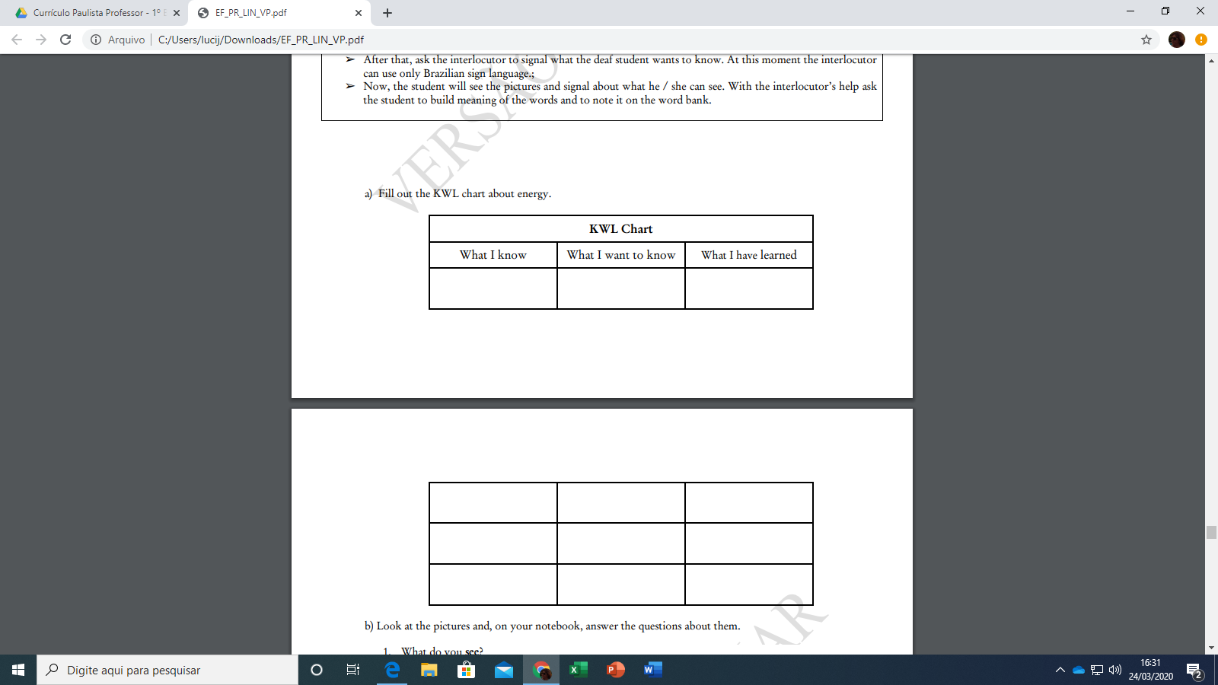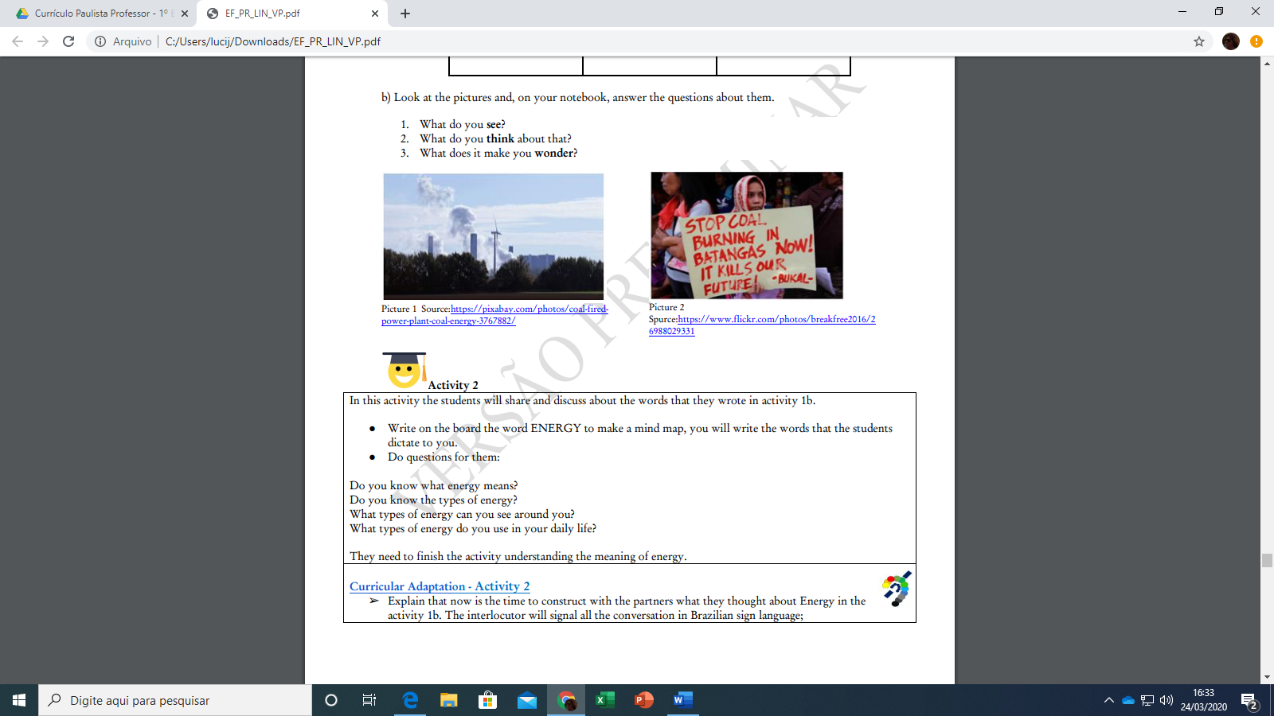

Look at the T-Chart and the picture to classify the energy sources. Use the sentence frame and talk to your friend.